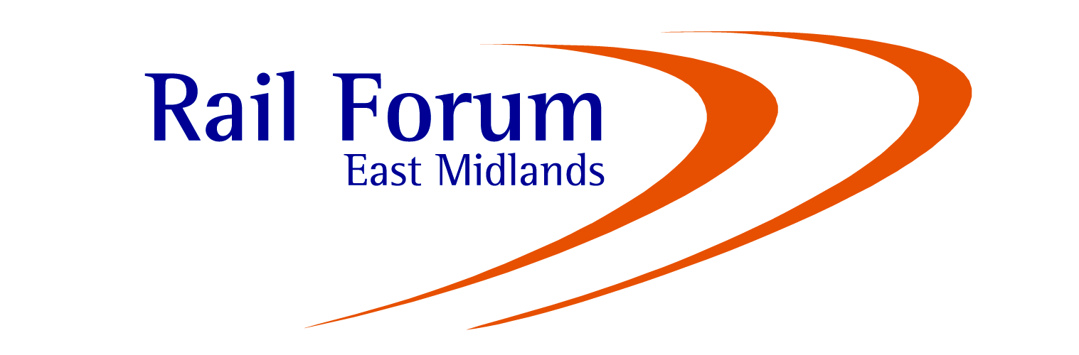

RFEM Charity Golf Day 2017

The Nottinghamshire Golf & Country Club, Cotgrave, Nottingham, NG12 3HB
Friday 6 October 2017

This year’s annual golf tournament will be held at The Nottinghamshire Golf & Country Club.

Rail Forum members are invited to compete in teams of 4, for the Neil Harvey Claret Jug, on this spectacular Nottingham course. All proceeds from the event will be donated to charities.

We hope that you will be able to support our event, and enjoy an excellent day of golf in good company, and beautiful surroundings.

Competition Details:
Time: From 9.00 am
Format: 4 Ball Better Ball, Best 2 Scores to count on each hole, with all 4 scoring on 18th
3/4 Handicap Allowance. Teams of either Men, Ladies or Mixed.
Dinner: On completion of the round at 5.30 followed by Prize Giving.
Prizes: 1st, 2nd and 3rd Team Prizes plus Nearest the Pin and Longest Drive.
Cost: £300.00 plus VAT per team – including meal (invoices will be issued).
………………………………………………………………………………………………………………………

ENTRY FORM
Closing Date: Friday 6 October 2017

2017 Rail Forum Charity Golf Tournament
TEAM NAME:
NAME HANDICAP
1.
2.
3.
4.

Please advise any special requirements (i.e. Starting Times, Vegetarian Meals, etc.)
_________________________________________________________________________________

_________________________________________________________________________________
Name: ________________________________
Company: ________________________________
Date: ________________________________
Please return to Sophia Blakey by e-mail to sophia@midlandsrail.co.uk.

